JEREMIAH NYAGAH NATIONAL POLYTECHNIC

ELECTRICAL AND ELECTRONICS DEPARTMENT

PRACTICAL ASSESSMENT II

50 MARKS
Qualification Code: 071306T4EEN
Qualification: Electrical Engineering Level 6
Unit Code: ENG/OS/PO/CR/05/6
Unit of Competency: Automate an Electrical Machine

INSTRUCTIONS TO THE CANDIDATE
- Time Allocated: 3 hours.
- Use provided materials only.
- Comply with I.E.E regulations.
- Assessor will record critical steps via audio-visual means.

Resources Provided:
- PLC (1)
- Conveyor motor (M1)
- Solenoid valve (for milk filling)
- Capping piston (M2)
- Labeling piston (M3)
- Bottle sensors (S1, S2, S3)
- Cap/Label sensors (2)
- Start/Stop push buttons (NO/NC)
- 4.0 mm² & 1.5 mm² PVC cables
- Mini-trunking, multimeter, tools

Problem: Milk Bottle Filling & Capping Automation
System Requirements:
- Auto Mode:
  - Conveyor (M1) runs until S1 detects a bottle → Stop M1 → Open valve to fill milk → Stop valve after level → Restart M1.
  - At S2: Stop M1 → Activate capping piston (M2) until cap sensor detects → Restart M1.
  - At S3: Stop M1 → Activate labeling piston (M3) until label sensor detects → Restart M1.
- Stop PB: Halts the cycle after completing current bottle.

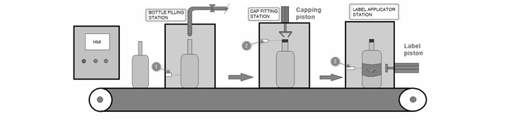

TASKS

TASK 1: Design (7 Marks)
- Draw:
  - Block diagram (PLC, sensors, actuators).
  - Wiring diagram (Include power supply, I/O connections).

TASK 2: PLC Programming (15 Marks)
- Write a ladder logic program to:
  - Start conveyor with Start PB.
  - Implement auto-mode sequence (S1 → Fill → S2 → Cap → S3 → Label).
  - Stop conveyor immediately with Stop PB.
- Label all operands.

TASK 3: Simulation (10 Marks)
- Simulate using software to verify:
  - Sensor-triggered valve/piston actions.
  - Conveyor start/stop logic.

TASK 4: Hardware Installation (10 Marks)
- Mount components on the board.
- Wire according to your diagram (neatness, color coding).

TASK 5: Testing (8 Marks)
- Download program to PLC.
- Test:
  - Auto-mode sequence (1 full cycle).
  - Emergency stop functionality.

